Dates
Référence

How to apply to beamtime at the AGLAE facility?

Rédacteur | Vérificateur | Approbateur | Version | Signatures | Date

Table des matières
1. Submission via the IPERION-HS transnational access 3
1.1. Who can apply? 3
1.2. Where to apply? 3
1.3. How to apply? 3
1.3.1. Registration 3
1.3.2. Selection of the techniques 4
1.3.3. Proposal submission 6
1.4. Contacts 7
2. Submission via the national and international access (except EU) 7
2.1. Who can apply? 7
2.2. Where to apply? 7
2.3. How to apply? 8
2.3.1. Registration 8
2.3.2. Proposal submission 8
2.4. Contacts 9

Submission via the IPERION-HS transnational access

Who can apply?

User Groups can apply for Transnational Access in case they meet the following conditions:
- the User Group Leader and the majority of the User Group members work in an institution/SME established in a Member State of the European Union, an EU Associated State or a developing country.
- the User Group Leader and the majority of the User Group members work in an institution/SME located in a country other than the country where the legal entity operating the infrastructure is established.
- only User Groups that are entitled to disseminate the foreground they have generated under the project are eligible to benefit from access free of charge to the infrastructure.

Where to apply?

The submission should be done on the IPERION-HS website.
http://www.iperionhs.eu/

How to apply?

This is a summary of the procedure to submit a proposal through the IPERION-HS website. A video demo is available on the website in the “how to access” page (http://www.iperionhs.eu/iperion-hsaccess/)

Registration
If it is your first visit on the website, a user account needs to be created by clicking on register in the top right corner.
Once the creation is effective, you have to log in before going further.
If you already registered, just log in and proceed.

Selection of the techniques
Before submitting your proposal, you have to go through the catalogue of techniques available in IPERION-HS. The catalogue can be found either by going in the menu SERVICES/Catalogue of services or directly at the following address : http://www.iperionhs.eu/catalogue-of-services/
Then you enter the FIXLAB catalogue by clicking on FIXLAB in the service platforms (NB: you can directly enter the FIXLAB catalogue through the menu SERVICES/FIXLAB).
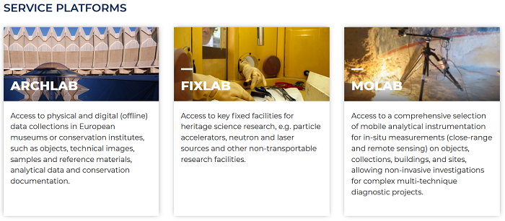
On the catalogue of all the FIXLAB techniques, AGLAE will be found in Ion Beam analysis techniques.
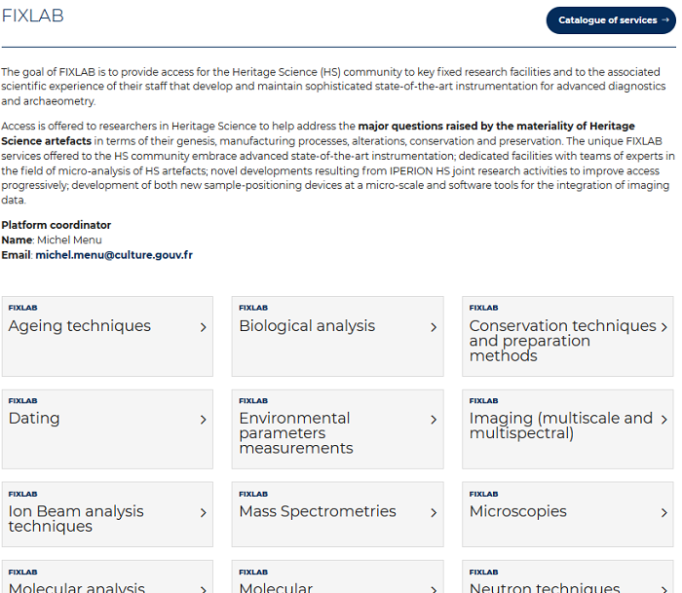
In Ion beam analysis techniques, you will have to enter each technique needed by clicking on the name of the technique. Note that AGLAE does not provide ERDA in the frame of the IPERION-HS Transnational Access.
When you enter the technique, you can now select the provider where you want to use that technique. To do that, you have to add the provider to your cart by clicking on the cart situated to the right of the provider name. For example, in the PIXE page:
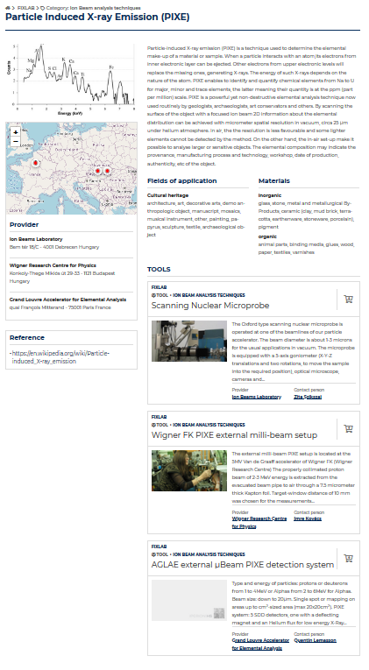
A pop up will show up to confirm that the item was added to the cart. Congratulations! Now the technique performed at the AGLAE facility is now in your cart!
You can now add another technique using the same procedure. Note that if you need several techniques, you must add all of them to the cart before proceeding to the next step.
As the website is a common deposit for all the IPERION-HS proposals, if your project needs a multiplatform analysis (e.g. AGLAE + multispectral analysis or X-ray imaging), you can do a common proposal by adding to your cart items from different providers.

Proposal submission
Once your cart is completed with all the techniques needed, you can proceed to the next step, the proposal submission. You have to visualize your cart by clicking on the cart situated on the upper right of the page.
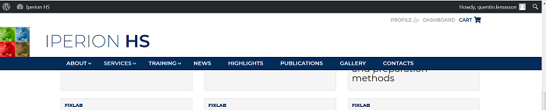

You can now click on Write a proposal
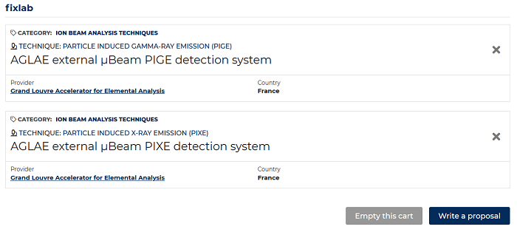
A form is displayed on the screen; you have to fill all the boxes (the ones with a red asterisk * are mandatory). The scientific description must be added as an attachment.
To upload the file online, the file should be saved in pdf and rename with the acronym of the proposal (acronym.pdf)

The description of the project must contain the following elements:
- Project summary (Be sure to include the novelty and/or added value of the proposed work) (max 300 words)
- Scientific background (max 500 words)
- Description of the planned work and experimental methods (experimental technique(s)) requested with justification, required set-up(s), measurement strategy, sampling area/point details (number, location, etc.), etc.) (max 600 words)
- Previous analysis on the artefact (max 300 words)
- Expected achievements (max 400 words)
- Impact and dissemination plan (max 400 words)
- References (min 5 – max 10)

If necessary, you can save your proposal as a draft. You will be able to access to your draft proposal in the cart, the Write a proposal button will be replaced by Edit draft proposal.
If your proposal is finished, you can click on Send proposal and the proposal is submitted. Be careful to accept the Terms and conditions at the end (by check the corresponding boxes).
Your proposal will no longer be editable and will go through the evaluation process once the deadline is over. The proposal is first evaluated by the provider to check its feasibility and, only if feasible, it will be evaluated by the peer review panel of IPERION-HS.

Contacts
If you need assistance concerning the techniques and experiments, you can contact the AGLAE staff: Quentin Lemasson, Claire Pacheco or Laurent Pichon (quentin.lemasson@culture.gouv.fr, claire.pacheco@culture.gouv.fr or laurent.pichon@culture.gouv.fr).
If you need help with the submission, you can contact the IPERION-HS user helpdesk (userhelpdesk@iperionhs.eu).

Submission via the national and international access (except EU)

Who can apply?

Any group that doesn’t fit in the groups described in the paragraph 1.1. i.e. only French user groups and groups from outside Europe.

Where to apply?

The submission should be done on the AGLAE call for proposal website.
https://aglae.sciencescall.org/

How to apply?

Registration
If it is your first visit on the website, a user account needs to be created by clicking on the arrow next to login and click on “Create an account” in the top right corner.
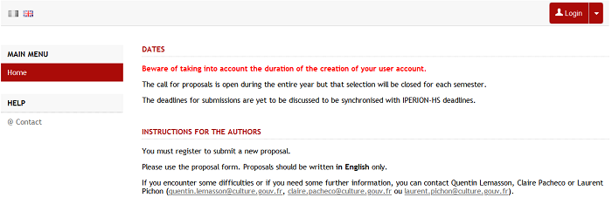
Once the creation is effective, you have to log in before going further.
If you already registered, just log in and proceed.

Proposal submission
Once you are logged in, a new menu will appear on the left. You can go on the My submitted projects tab. There, you can download the template for the proposal and submit a proposal by clicking on the Submit a project button.
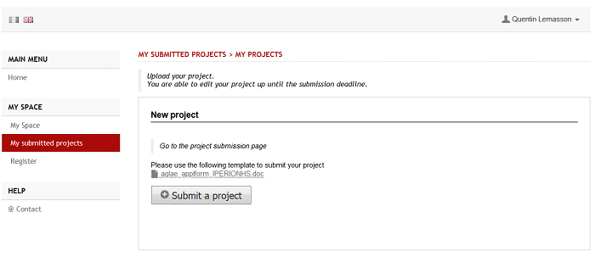

Follow the following steps
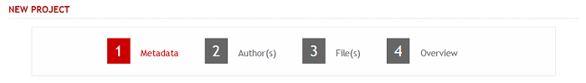
1 Metadata: Title of the project
2 Author(s)
3 File(s): You can upload the template file completed with your project. Pdf and doc or docx formats are accepted. All the formats will be converted to pdf. You can add supplementary data (e.g. list of objects) but the scientific description of the project should be filled in the template.
4 Overview: In the overview, you can check your submission. You can then validate using the Submit/Save button. Note that project can be edited latter until the submission deadline.

Contacts
If you need assistance concerning the techniques and experiments, you can contact the AGLAE staff: Quentin Lemasson, Claire Pacheco or Laurent Pichon (quentin.lemasson@culture.gouv.fr, claire.pacheco@culture.gouv.fr or laurent.pichon@culture.gouv.fr).
If you need help with the submission, please contact Quentin Lemasson.

